Assignment 5

Synscan

To detect an open port:

If a syn packet is sent it must be replied with a syn and ack packet, by detecting these packets using wireshark we can detect an open port.

The filter used here is =“tcp.flags.syn==1 && tcp.flags.ack==1”

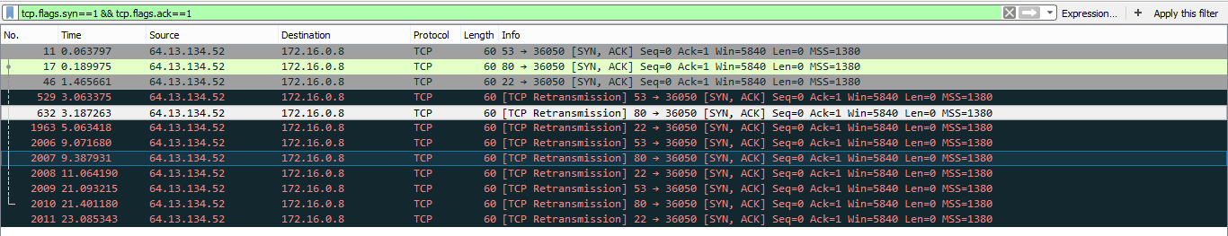

Open ports are=53,22,80.

To detect a closed port

If a syn packet is sent it gets responded by rst and ack packet.

The filter used here is = “tcp.flags.ack==1 && tcp.flags.rst==1”



Closed ports are=113,25,70,31337.